App Version

App version module is used to specify the mobile app version number, name and release date. When ever we have an update to release in our mobile app, then we will specify the particular app platform and its version and its details.  
  
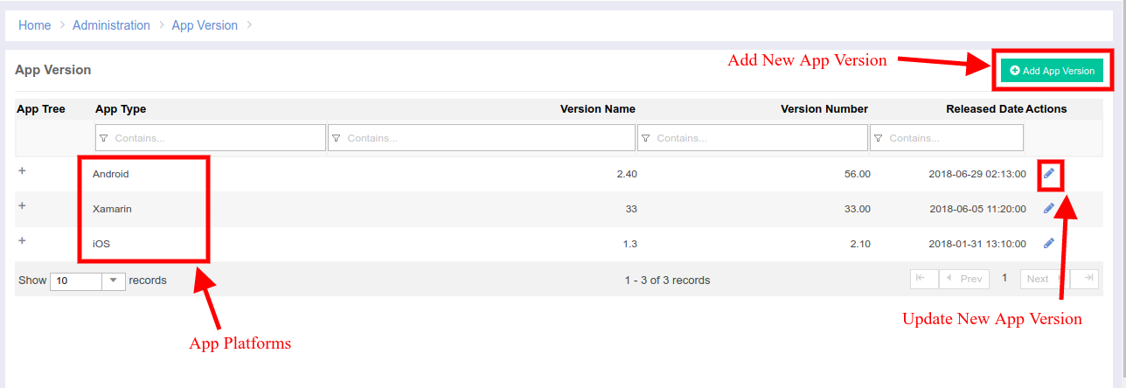  
  
**1) Add New App Version:** This button is used to add new App Platforms

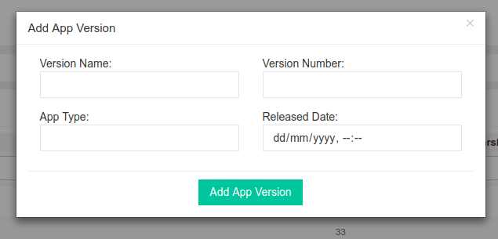

**2) Update New App Version:** This button is to edit/update the new App Version   
  
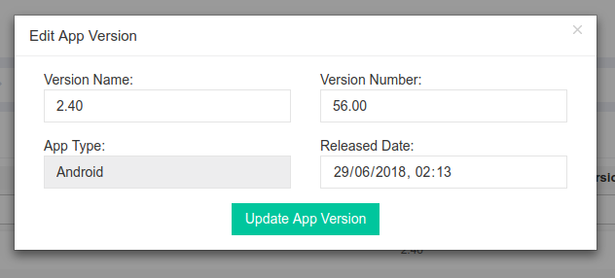

Code Details:  
Module Name: **AppVersion**Url: [**http://portal.ebutor.com/appversion**](http://portal.ebutor.com/appversion)Database: **app_version_info** and **app_version_history tables**Features:

Add App Permission [**APP003**]  
 Edit App Permission [**APP002**]  
  
The functions **versionList()** retrieves the json list of the app version records and **addVersion()** and **updateVersion()** adds and update the records of the app version in the table  
  
CP Mobile API:  
As it was said earlier, we use app version module to control the app version and to make the update of the app.  
**Api URL:** <http://portal.ebutor.com/cpmanager/versioncheck>  
**Api Input:**   
 data: {

"number": "35",

"type": "android",

"device_id": "1d3c8d4d7a22bb97",

"ip_address": "10.175.21.216",

"reg_id": "fEPke5laHM8:APA91bH5890E5POD-RUXKHYSD2dI0A5JT6_9FT9V4FKrSBlWu0b0HPS3x8NYsbX17Dgyf_cDZVNDlkb_R_aqsSIh7v5202IbyKhOslIcDopZMaCi_c-zKSKpWeyPvtA4MmajymJ-HUy8",

"platform_id": "5004",

"user_id": ""

}

**Api Output:**  
 {

"status": "update",

"versionUpdateStatus": "1",

"version_number": "10"

}

Every time, when the App loads, this api will be called, it will check for the current app version. If the **versionUpdateStatus** is set to “1” then, the user is forced to update the app from the playstore.